Update/delete the yellow highlighted areas with your events details

XXXX XXXX Traffic Management Plan TEMPLATE
Date - XX XXX 202X from XXam-XXpm
Reason - XXXXXX
ORGANISATION DETAILS
Name of Organisation
Contact Person
Contact Phone Number
Start Time
End Time
Estimated number of people expected to attend this event

ROAD CLOSURE AND/OR RESTRICTION DETAILS
1 Name of street/road (include intersecting roads)
Closure Date |  |  |  |  | Reopen Date
Closure Time |  |  |  |  | Reopen Time
2 Name of street/road (include intersecting roads)
Closure Date |  |  |  |  | Reopen Date
Closure Time |  |  |  |  | Reopen Time
3 Name of street/road (include intersecting roads)
Closure Date |  |  |  |  | Reopen Date
Closure Time |  |  |  |  | Reopen Time
4 Name of street/road (include intersecting roads)
Closure Date |  |  |  |  |  | Reopen Date
Closure Time |  |  |  |  |  | Reopen Time
5 Name of street/road (include intersecting roads)
Closure Date |  |  |  |  |  | Reopen Date
Closure Time |  |  |  |  |  | Reopen Time
6 Name of street/road (include intersecting roads)
Closure Date |  |  |  |  |  | Reopen Date
Closure Time |  |  |  |  |  | Reopen Time
If more than three (6) road closures required for your event, attach an additional page with details

Do the roads requested for closure adjoin roads that are owned or under the control of another Government Authority (either state or local government)? Yes / No

Have you notified the neighbouring Government Authority of your intentions to close the above-mentioned roads? Yes / No

Will your event be taking place in other Local Government Areas? Yes / No
If, so which ones?

Traffic Marshals
Traffic Control Devices must be installed by persons with relevant experience and knowledge in Traffic Management - ideally individuals with a Work Zone Traffic Management Certificate, in accordance with the Australian Standard (AS 1906.4).

Please Note to provide details on where marshals will be positioned for this event on your site map

Please provide the names of the officials involved with installing and/or monitoring traffic control devices at this event.
NAME | ROLE(S)

Dealing with a vehicle accident
Please provide details of the steps that will be taken in the event of a vehicle accident occurring that is associated with your event.

Attach a map of the road and area below
Please attach a site map of the event showing
- Access and egress points for
  - emergency services
  - vehicles, and
  - people (including persons with a disability)
- Proposed parking areas for the event, including direction of traffic flow
- Alternate routes and transport options
  - Please provide details of alternative transport options to and from the event.
- Where the road closure blocks access to property, please provide details on how locals are able to gain access during the event.
- Please provide details of traffic detours in the vicinity of the event site that may be implemented during the event to ensure that inconvenience to local residents is kept to a minimum.
Copy and paste the ledger icons onto your plan to show changes, noting to change the icon size to suite the plan size. Please include additional icons if not included below
Traffic Management Plan Ledger
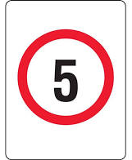 | 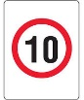 | 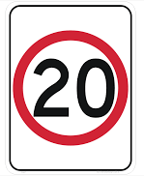 | 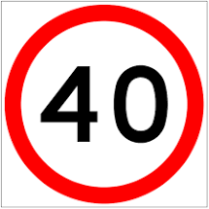
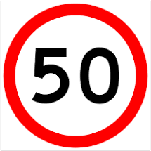 | 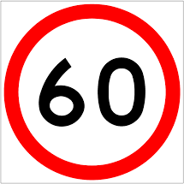 | 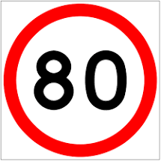
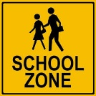 | 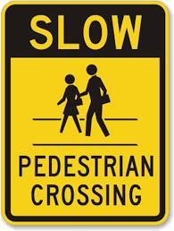
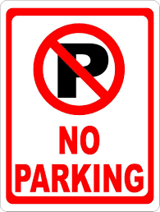 | 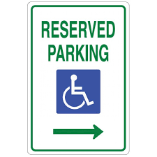 | 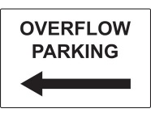
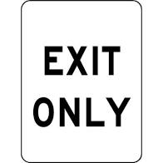
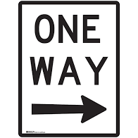 | 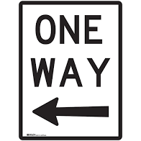 | 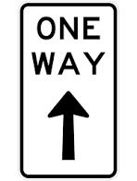
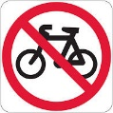 |  | To show flow of traffic | To show flow of traffic

